慈濟大學人文社會學院專題演講

主講：郭崇信博士
講題：多元文化諮商—加拿大的研究與臨床經驗
時間：96年12月7日(星期五)10:10-12:00
地點：慈濟大學人社院區教學研討室
(花蓮市介仁街67號E棟211)
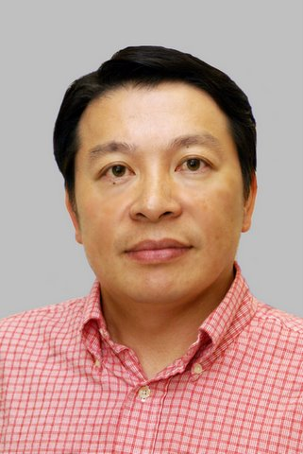
郭崇信博士為美國內布拉斯加大學(林肯校區)（University of Nebraska-Lincoln）諮商心理學博士。目前任職於加拿大安大略省溫莎大學（University of Windsor, Ontario in Canada）臨床心理學副教授，專攻心理與文化議題，具加拿大臨床心理師執照，本年度接受國科會聘請至國立師範大學教育心理與輔導學系之客座教授。
Dr. Ben C. H. Kuo is an associate professor of clinical psychology in the Department of Psychology at the University of Windsor, Ontario in Canada. Dr. Kuo is also a registered and practicing psychologist in Ontario. Dr. Kuo is currently in Taiwan for a year as a National Science Council Visiting Professor at the Department of Educational Psychology and Counseling in the National Taiwan Normal University. Dr. Kuo received his undergraduate and master's degrees from the University of Toronto (CANADA), and his Ph.D. degree from the University of Nebraska-Lincoln (USA).
His research is in the broad areas of cross-cultural psychology and multicultural counseling/psychotherapy. He has published research on acculturation, cultural stress and coping, professional help-seeking attitude and behaviors, and cultural adjustment and mental health among immigrants and culturally-diverse populations in Canada and the U.S. Dr. Kuo's research extends across the life span, including studies of Asian adolescents, international students, university students, and elderly. His works appear in more than 30 publications and presentations in various international, academic journals and conferences.

