Curriculum Vitae
一、基本資料
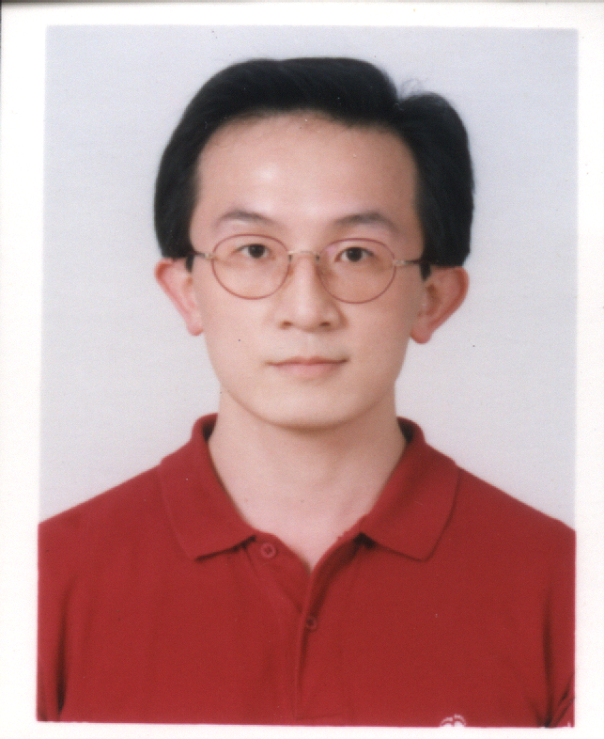
Name: Chuen-Lin Huang 黃 春 霖
Birthday/ Sex: 18th/ May/ 1969, Male, 臺灣省嘉義市人
Language : 國語、台語、英語
Address:臺北市11058信義區莊敬路423 巷2 弄13號2樓
聯絡方式:耕莘醫院A棟8F, 醫學研究中心TEL: 02-22193391 # 66828
E-mail: springysl@yahoo.com.tw or springysl@gmail.com
Mobile Phone: 0937-512-136

二、主要學歷 由最高學歷依次填寫，若仍在學者，請在學位欄填「肄業」。
學校名稱 | 國別 | 主修學門系所 | 學位 | 起訖年月(西元年/月)
陽明大學 | 臺灣 | 神經科學研究所 | 博士 | 自1995/09至1999/06
台北醫學大學 | 臺灣 | 醫學研究所 | 碩士 | 自1993/09至1995/06
輔仁大學 | 臺灣 | 食品營養系 | 學士 | 自1989/09至1993/06
 |  |  |  | 自 / 至 /

三、現職及與專長相關之經歷 指與研究相關之專任職務，請依任職之時間先後順序由最近者往前追溯。
服務機構 | 服務部門／系所 | 職稱 | 起訖年月(西元年/月)
現職：耕莘醫院 | 醫學研究中心 | 副研究員 | 自2005/11至今
經歷：中央研究院 | 生物醫學科學研究所 | 博士後研究員 | 自1999/06至2003/12
臺北醫學大學 | 醫學系 | 博士後研究員 | 自2004/01至2004/08
基因數碼科技股份有限公司 | 研發部 | 副研究員 | 自2004/09至2005/10
四、專長 請自行填寫與研究方向有關之學門及次領域名稱。

- 神經科學 | - 神經藥理學 | - 訊息傳遞 | - 蛋白質交互作用

五、論文著述：
A.歷年著作目錄(Pubications):
1. Lee H.-M and Huang C-L. (1997) NMDA inhibits carbachol-stimulated PI resynthesis. Neurochemical Research 22: 607-614. SCI
2. Pan S.H., Mou D.C., Huang C-L. and Lee H.-M. (1997) Pentoses react with BSA to form AGEs faster than hexoses in vitro. J. Chinese Nutrition Soc. 22: 193-205.
3. Lee, H.-M., Tsai K.-J., Lin C.-H., Huang C-L., amd Tung C.-S. (1998) Arecoline desensitizes carbachol-stimulated phosphatidylinositol breakdown in rat cortical slices. J. Neurochem. 70: 1189-1198. SCI
4. Huang C-L., Chen H-C., Huang N-K., Yang D-M., Kao L-S., Chen J-C., Lai H-L. and Chern Y.: (1999) Modulation of dopamine transporter activity by nicotinic acetylcholine receptors and membrane depolarization in rat pheochromocytoma PC12 cells. J. Neurochem. 72(6): 2437-2445 SCI
5. Huang N-K., Lin Y-W., Huang C-L., Messing R. and Chern Y.: (2001) Activation of protein kinase A and atypical protein kinase C by A_{2A} adenosine receptors antagonizes apotosis due to serum deprivation in PC12 cells. J. Biol. Chem. 276:13838-13846 SCI
6. Huang C-L., Huang N-K., Shyue S-K and Chern Y.: (2003) H₂O₂-induces loss of rat dopamine transporter activity: a calcium-dependent oxidative mechanism.J. Neurochem. 86: 1247-1259. SCI
7. Lee Y-C., Chien C-L., Sun C-N, Huang C-L., Huang N-K., Liao W-l., Liu F-C., Wang L., Tai M-H., Lin T-N and Chern Y.: (2003) Characterization of the rat A_{2A} adenosine receptor gene: A 4.8 kb promoter-proximal DNA fragment confers selective expression in the central nervous system. Euro.J. Neurosci. 18: 1786-1796 SCI
8. Chou R-L., Huang C-L., Lai H-L., Kao Y-Y. and Chern Y. (2004) Regulation of the type VI adenylyl cyclase activity by snapin. J. Biol. Chem.279 (44): 46271-46279 SCI
9. Chiang M-C., Lee Y-C., Huang C-L and Chern Y. (2005) CREB contributes to suppression of the A2A adenosine re ceptor promoter by mutant Huntingtin with expanded polyglutamine residues. J.Biol. Chem.280: 14331-14340 SCI
10. Lin YL, Lee YC, Huang C-L, Lai WL, Lin YR, Huang NK. (2006) Ligusticum chuanxiong prevents rat pheochromocytoma cells from serum deprivation-induced apoptosis through a protein kinase A-dependent pathway. J Ethnopharma. doi:10.1016/j.jep.2006.08.012 (in printing) SCI
11. Chen HM, Lee YC, Huang C-L, Liao WC, Lai WL, Lin YR, and Huang NK. (2006) Methamphetamine down regulates the expressions of peroxiredoxins in the rat pheochromacytoma cells. FEBS Lett (in submitting)
12. Lin YL, Huang C-L, Lee YC, Lai WL, Lin YR, Huang NK. (2006) Ligusticum chuanxiong prevents rat pheochromocytoma cells from serum deprivation-induced apoptosis. J Ethnopharma. (in revising)
13. Huang C-L., Huang Y-H., Wang S-H. and Lee Y-C. (2007). Silence of protein kinase C iota induces cell growth arrest and cell death in ovarian cancer. (in preparation).
14. Wang S-C., Oh R., Huang C-L., Lai H-L and Chern Y. (2007) Characterization of type V adenylyl cyclase interacting proteins. (in preparation).
15. Lee Y-C., Wang S-H., Huang Y-H and Huang C-L. (2007) Two novel genes over-expressing in ovarian cancer that could act as potential therapeutic targets. (in preparation).
16. Huang C-L., Wu J-S. Horng A., Chou R-L., Lai H-L and Chern Y. (2007) Regulation of neuronal
dendrite branching formation by snapin. (in preparation).
17. Huang C-L., Huang N-K., Lee Y-C and Chern Y.: (2007) Regulation of dopamine transporter activity by snapin, a synaptic vesicle membrane protein. (in preparation).

B. 研討會議摘要(Symposium abstract):
1. Huang C-L. and Lee H-M. (1995) Effects of NMDA on carbachol-stimulated phosphatidylinositol resynthesis in rat brain cortical slices. Symposium of the 10th Joint Annual Conference of Biomedical Sciences, Taipei, Taiwan.
2. Huang C-L., Chen H-C., Lai H-L and Chern Y. (1998) Membrane deolarization inhibites the rat dopamine transporter activity in rat pheochoromacytoma PC12 cells. Symposium of the 5th Joint Annual Conference of Cellular and Molecular Sciences, Taipei, Taiwan.
3. Huang C-L. and Chern Y. (1998) Inhibition of dopamine transporter activity in PC12 cells by H₂O₂. Symposium of the 28th Joint Annual Conference of Neuroscience, LA, California,U.S.A.
4. Huang C-L. and Chern Y. (2000). H2O2-induced loss of rat dopamine transporter activity through a calcium- and wortmannin- sensitive pathway. Symposium of the 40th Joint Annual Conference of Cell Biology, SF, California, U. S. A.
5. Huang C-L. and Chern Y. (2003). H2O2-induces loss of rat dopamine transporter activity: a calcium-dependent oxidative mechanism. Symposium of the 32th Joint Annual Conference of Neurocsience, New Olean, Leuis Anna, U. S. A.
6. Chou R-L., Huang C-L., Lai H-L and Chern Y. (2003) Regulation of the type Ⅵ adenylyl cyclase by snapin. Symposium of the 32th Joint Annual Conference of Neurocsience, New Olean, Leuis Anna, U. S. A.
7. Chiang M-C., Lee Y-C., Huang C-L and Chern Y. (2003) Suppression of the A_{2A} adenosine receptor promoter by mutant Huntingtin with expanded CAG trinucleotide repeat. Symposium of the 32th Joint Annual Conference of Neurocsience, New Olean, Leuis Anna, U. S. A.
8. Lee Y-C., Wang S-H., Huang Y-H and Huang C-L. (2005) Two novel genes over-expressing in ovarian cancer that could act as potential therapeutic targets. Symposium of the 13th Joint Annual Conference of Cellular and Molecular Sciences, Taipei, Taiwan.
9. Huang C-L., Huang Y-H., Wang S-H. and Lee Y-C. (2005). Atypical protein kinase C might be involved lysophosphatidic acid-induced signaling in ovarian cancer. Symposium of the 13th Joint Annual Conference of Cellular and Molecular Sciences, Taipei, Taiwan.
10. Huang C-L. and Chern Y.(2006): The Mechanism of Hydrogen Peroxide-Induced Dysfunction of Dopamine Transporter” : It Might Be Involved in The Formation of Dopaminergic Neurotoxicity. Symposium of the 21th Joint Annual Conference of Biomedical Sciences, Taipei, Taiwan.

C. 博碩士論文名稱:
(1).博士論文名稱:
Regulation of Dopamine Transporter Activity in The Rat Kidney Pheochromocytoma PC12 Cells.
(2).碩士論文名稱:
Effects of NMDA on Carbachol-Stimulated Phosphatidylinositol Resynthesis in Rat Brain Cortical Slices.

六、過去曾執行之相關計畫成果:
(一)、主要研究主題
(A).Dopamine transporter activity regulation-Establishment of Stable Cell line
Huang C-L., Chen H-C., Huang N-K., Yang D-M., Kao L-S., Chen J-C., Lai H-L. and Chern Y.: (1999) Modulation of dopamine transporter activity by nicotinic acetylcholine receptors and membrane depolarization in rat pheochromocytoma PC12 cells. J. Neurochem. 72(6): 2437-2445 SCI
Huang C-L., Huang N-K., Shyue S-K and Chern Y.: (2003) H₂O₂-induces loss of rat dopamine transporter activity: a calcium-dependent oxidative mechanism.J. Neurochem. 86: 1247-1259. SCI

(二)、其他參與之研究主題
(B).Adenosine A_{2A} receptor signaling-Cell Death
Huang N-K., Lin Y-W., Huang C-L., Messing R. and Chern Y.: (2001) Activation of protein kinase A and atypical protein kinase C by A_{2A} adenosine receptors antagonizes apotosis due to serum deprivation in PC12 cells. J. Biol. Chem. 276:13838-13846 SCI

(C). Adenosine A_{2A} receptor-Transgenic Mice
Lee Y-C., Chien C-L., Sun C-N, Huang C-L., Huang N-K., Liao W-l., Liu F-C., Wang L., Tai M-H., Lin T-N and Chern Y.: (2003) Characterization of the rat A_{2A} adenosine receptor gene: A 4.8 kb promoter-proximal DNA fragment confers selective expression in the central nervous system. Euro.J. Neurosci. 18: 1786-1796 SCI

(D). Adenylyl Cyclase Type VI-Interacting Proteins Screening-Yeast Two Hybrid System
Chou R-L., Huang C-L., Lai H-L., Kao Y-Y. and Chern Y. (2004) Regulation of the type VI adenylyl cyclase activity by snapin. J. Biol. Chem.279 (44): 46271-46279 SCI

(E). Adenosine A_{2A} receptor-Huntington Disease-Neuronal Primary Culture
Chiang M-C., Lee Y-C., Huang C-L and Chern Y. (2005) CREB contributes to suppression of the A2A adenosine re ceptor promoter by mutant Huntingtin with expanded polyglutamine residues. J.Biol. Chem.280: 14331-14340 SCI

七、執行中之研究計畫
- 以乳凸狀甲狀腺癌細胞株做為篩藥的技術平台來尋找具有治療甲狀腺癌效果之中草藥(耕莘醫院 2006/09~2007/08)
- 利用去氧核醣核酸微陣列晶片與蛋白質體學之方法研究乳凸狀甲狀腺癌的基因與蛋白質表現之差異性(耕莘醫院2006/09~2007/08)
- 尋找具有保護多巴胺神經元的中草藥並探討其藥理作用機制(耕莘醫院2006/12~2007/11)

八、專長領域
1. Neuroscience
2. Neurochemistry
3. Neuropharmacology
4. Neurotransmitter Transporters
5. Signal Transduction
6. Protein-Protein Interaction

九、專長技術
Molecular Biology:
PCR.
CsCl DNA preparation and subcloning.
RNA preparation
Western blot.
Southern blot.
Dot blot.
DNA transfection.
E. Coli. Competent Cell Preparation
Yeast Two Hybrid (Libraries screening and protein-protein interaction).
Adenovirus infection and preparation
siRNA design and siRNA transfection
Quantitative real time PCR

Cellular Biology:
Cell culture system:
Cell lines: PC12-, CHOP-, COS-, C6 glioma, HEK293-, sf21, mouse cerebral endothelial cells. Ovarian cancer cell lines: TOV112D, OC314 cells. Lung cancer cells: A549 cells. Epithelial cells.
Primary cultures:
Neuronal cultures:
Embryonic Hippocampal-, Striatal- and Cortical primary Neuronal Culture.
Immune culture system:
T cells primary culture in Lymph node and B cells primary culture in spleen.
In vitro immunoprecipitation.
Preparation of plasma membrane, cytosol and nuclear.
Protein kinase activity assay
Transfection: Stable Cell Line Selection and Establishment.
Primary Neuronal Culture transfection.
Immunostaining : cell lines, primary neuronal culture and brain tissue.
Confocal image analysis.
Reporter activity assay: Luciferase activity, β-galactosidase activity assay and x-gal staining.
Apoptosis analysis: MTT assay, TUNEL staining, DNA fragmentation.
FACS (Flow cytometer analysis).
Fura-2 intracellular Ca²⁺ measurement.
Zymorgraphy-Matrix Metalloprotease Activity assay
Measurement of inositol phosphates, phosphoinositol, phosphatidic acid
Thin Layer Chromatography (TLC) assay
Neurotransmetter release assay.
Neurotransmetter transporter activity assay

Animal study:
Brain isolation and perfusion.
Brain slices preparation
Brain synaptosomes preparation
Brain Microinjection (in mouse and rat brain)
Transgenic mice handling and management.
Polyclone antibody generation

