CHAO AGNES HSlUNG
Curriculum Vitae
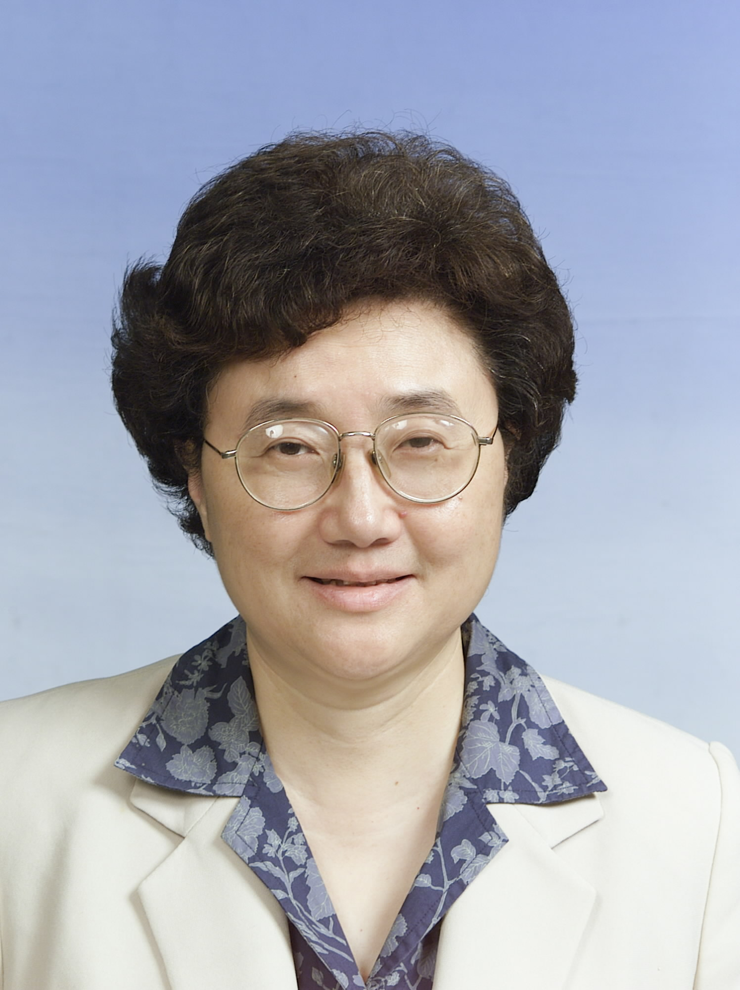
Division of Biostatistics and Bioinformatics,
National Health Research Institutes,
No. 35, Keyan Road, Zhunan Town, Miaoli County 350
Taiwan, R.O.C.
Phone: 886-37-246-166 ext:36100
Fax : 886-37-586-467
E-mail: hsiung1@nhri.org.tw

Education

l975 Ph.D., Statistics, Columbia University, New York
l973 M.A., Statistics, Columbia University, New York
l972 B.S., Mathematics, National Tsing-Hua University, Taiwan

Professional Experience
1) 2002 Jan.- Present Distinguished Investigator and Director, Division of Biostatistics and Bioinformatics /
National Health Research Institutes
2) l997 -2001 Dec. Investigator and Director, Division of Biostatistics / National Health Research Institutes
3) l992- 2004 Director, Statistical Center / Taiwan Cooperative Oncology Group
4) 1985-2000 Research Fellow, Institute of Statistical Science / Academia Sinica, Taipei
5) 1998-1999 Acting Director, Department of Research Resources / National Health Research Institutes
6) 1981-1998 Professor, Department of Mathematics / National Central University, Taiwan
7) 1989-1990 Visiting Professor, Department of Statistics / Columbia University
8) l976-1981 Associate Professor, Department of Mathematics / National Central University, Taiwan
9) l975-1976 Assistant Professor, Department of Mathematics / Cornell University

Awards and Honors
Elected Member, International Statistical Institutes, 1985
SunYat-Sen Award for Outstanding Research,1988
Outstanding Research Award, National Science Council 1991-1993
Excellence Research Award, National Science Council 1988-1991,1993-1995
Fellow, Institute of Mathematical Statistics,elected 1994

Service and Committees
Consultant to the TCOG (Taiwan Cooperative Oncology Group ), 1988-

Associate Editor, Statistica Sinica, 1991-1999

Member, Board of Directors, International Chinese Statistical Association, 1993-1996

Member, College Exam. Research Committee, Center for College Entrance Examination, 1992一1994

Advisor, Section of Biostatistics, Veteran General Hospita1, Taipei, 1995-

Chair, Panel for Statistical Sciences, National Science Council, 1995-1997

Member, Committee of Drug Evaluation, Bureau of Pharmaceutical Affairs, Department of Health (DOH), 1995-

Coordinating member, Planning Committee for Biostatistics, National Health Research Institute, 1996

Chair, Data and Safety Monitoring Committee, TCOG, 1996-2004

Member, Joint Institutional Review Board, 1996-

Chair, Audit Committee, TCOG, 1997-

Associate Editor, Journal of the Chinese Statistical Association, 1997-

Member, Advisory Committee, National Health Insurance Research Databank, 1998-

Editor, ICH in Taiwan Bulletin, 1999-2002

Member, Planning Committee for Bioinformatics Section, National Science Council, 2000

Member, Board of Directors, Taiwan Bioinformatics Society, 2000-2004

President, International Chinese Statistical Association, 2001

Chair, Bioinformatics Section Working Group, National Program on Genomic Medicine, 2002-2005

Consultant to the Center for Disease Control (CDC) –Taiwan, 2003-

