摘要格式說明

一、摘要內容應合乎：
  - 以英文表遠者，請務必另附作者及單位的中英文對照說明。
  - 編輯軟體：請以WORD繕打。
  - 紙張大小：以A4一頁為限。
  - 邊界設定：上下左右均為3.0 cm。
  - 文字：除中文為標楷體外，全部使用Times New Roman，字型大小為12。
  - 行距：單行間距（Single space）。
  - 標題：全部大寫。
  - 報告者在其姓名之後附加 * 號，指導教授在其姓名之後附加 # 號。

二、範例：
THE INTERACTION BETWEEN ENTEROVIRUS TYPE 71 2A
AND CELLULAR CATALASE PROTEINS

Ye-Jen Wang^{1,}*, Y-L Juang², S-Y Lo^{3,#}
Department of Life Science¹, Microbiology², and Department of Laboratory Medicine and Biotechnology³, Tzu Chi University, Hualien, Taiwan
王以仁¹*、莊育梩²、羅時燕^{3#}
慈濟大學生命科學系¹
慈濟大學微生物學科²
慈濟大學醫學檢驗生物技術學系³

Infection with enterovirus 71 (EV71) can cause hand-foot-and-mouth disease, herpangina, and even encephalitis. EV71 is a member of Picornaviridae family. It has been demonstrated that EV71 2A protein can induce apoptosis in the cells, which may be related to viral pathogenesis.
We used yeast two-hybrid system to search for cellular protein(s) interacting with EV71 2A protein. The C-terminus of catalase protein was fished out by this approach. The binding domain of catalase with EV71 2A protein was also identified using yeast two-hybrid system.
Inhibition of catalase will increase oxidative stress and cause apoptosis in the cells. We are studying the effect of EV71 2A on catalase activity now.

海報規格說明

- 印製尺寸：博士生：A0橫式(即120 x 82 cm)。
碩士生暨大學部同學：A0直式(即82x120cm)。
- 可至電算中心多媒體教室登記列印。
- 請務必於5月29日(一)貼妥完成，並於評分結束後當日帶離。
- 建議格式如下：
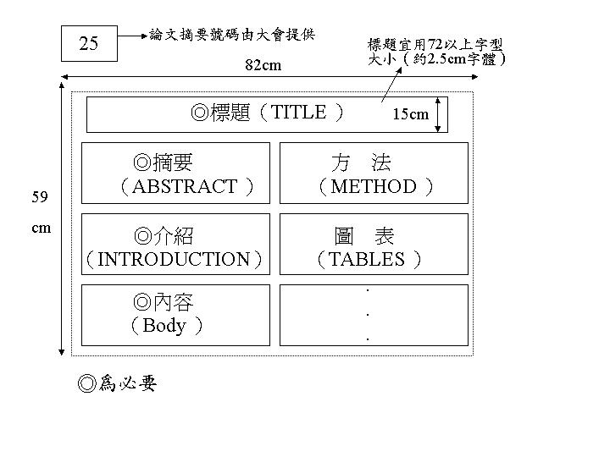
120

四、展覽板張貼說明 (長180CM×寬90CM)
板長180cm

板寬90cm
Ａ同學
Poster
Ｂ同學
Poster
海報寬120cm

海報長82cm

